CERTIFICATE

This is to certify that Harsh Agrawal, Siddharth Verma and Soumya Agnihotri of class XII-‘A’ of Kendriya Vidyalaya No. 1, Indore have successfully completed their final project of Computer Science for the session 2016-17 using all the efforts.

Mr S.P. Saraswat Mr Manish Kumar Gupta

Principal PGT (Computer Science)

ACKNOWLEDGEMENT

The completion of this project owes many thanks to various people who help us doing our project work and we would like to thank all of them.

We are highly indebted to Mr. S.P. Saraswat, Principal, Kendriya Vidyalaya No.1, Indore, for providing the infrastructure required for the successful completion of this project.

It gives us immense pleasure and pride to thanks Mr. Manish Kumar Gupta for the timely guidance and support that we have been receiving throughout this project.

Last but not the least; we would like to take this opportunity to thank our parents, friends and all the colleagues and everyone who helped us directly or indirectly during the entire span of this project.

Harsh Agrawal

Siddharth Verma

Soumya Agnihotri

Why C++

1. It supports Object-Oriented Programming (OOP) concepts.

* Data Abstraction
* Data Encapsulation
* Modularity
* Inheritance
* Polymorphism

1. OOP’s concepts more reliable, more easily maintained programs.
2. It has ease of fabrication and maintenance.
3. Easy redesign and extension.
4. User-defined operators and library functions are supported.
5. The availability of a consistent interface to objects lessens code duplication and thereby improves code re-usability.
6. Write code once and use more than one time.
7. Readability:  Easy to read or understand.
8. Portable language (writing a program irrespective of operating system as well as Hardware).
9. It has relatively clear and mature standard rather than other languages.

WORKING DESCRIPTION

Our program is a Menu based program made for storing details of a criminal.

It has six parts they are-

1. To add records

* This option will ask the user to enter the address, age, Convict code, Name, Sex.
* User can also input the details of court, state, crime, Act.
* User can input description like Face description, enter color, enter height and identification marks.
* Complete address of police station, FIR no. and Date of Arrestment can be added.

1. To modify records.

* User can modify all the records that were entered by them.

1. To display record.

* All the records were displayed order wise on the screen that was saved in the data file.

1. To delete record.

* To delete the record user has to enter convict number and then record will be deleted.

1. To List.

* List of all the details of criminal were displayed on the screen

1. Quit

HEADER FILES

* #include<iostream.h>
* #include<conio.h>
* #include<stdio.h>
* #include<fstream.h>
* #include<string.h>
* #include<stdlib.h>
* #include<iomanip.h>

USER DEFINE FUNCTIONS

* input()
* output()
* delete_rec()
* charcon_no[]
* dcheck(char n[])
* display()
* remove()
* menu()
* modify()
* list()
* empty()
* concheck(char b[])

CODING

#include<iostream.h>

#include<conio.h>

#include<stdio.h>

#include<fstream.h>

#include<string.h>

#include<stdlib.h>

#include<iomanip.h>

/************************************************* Structure for Date

*************************************************/

struct date

{

int d;

int m;

int y;

};

/*************************************************

Structure for Details of Crime of Criminal

*************************************************/

struct court

{

char crime[20];

char act[20];

char cour[20];

char state[20];

};

/************************************************* Structure for Physical Description of Criminal

*************************************************/

struct descp

{

char colour[20];

char face[20];

char imark[20];//IDENTIFICATION MARKS(DEFORMITIES ETC.)

char height[6];

};

/*************************************************

Structure for Details of F.I.R.

*************************************************/

struct police

{

char station[50];

char fir_no[10];

date date_arrest;

};

/*************************************************

Class ' CRIMINAL ‘for getting all information about

*************************************************/

class criminal

{

char name[20];

char sex[3];

char conno[10];

char age[4];

char address[50]; //ADDRESS OF CRIMINAL BEFORE ARREST.

court COURT;

police POLICE;

descp des;

public:

int ncheck(char arr[]); //FUNCTION TO CHECK THAT INPUT IS NOT

// NUMERIC.

int s_check(char a[]); // FUNCTION TO CHECK THAT THE INPUT FOR

// SEX HAS ONLY 1 CHARACTER IN M OR F ONLY

void input(void);

void output(void);

void delete_rec(char con_no[]);

int dcheck(char n[]);

void display();

void remove();

int menu();

void modify();

void list();

void empty();

int concheck(char b[]);

};

// ====================> End of Class Criminal<=============================

/*************************************************

Function for Checking Weither Input is Correct

*************************************************/

int criminal::ncheck (char arr[])

{

int i=0;

while (arr[i]!='\0')

{

if (((arr[i]>64)&&(arr[i]<92))||((arr[i]>95)&&(arr[i]<124))

||(arr[i]==' '))

{

i++;

continue;

}

else

{

cout<<"\nINCORRECT INPUT. TRY AGAIN !!\n ";

return 0;

}

}

return 1;

}

/*************************************************

Function to Check whether Sex is Given Correctly

*************************************************/

int criminal::s_check(char a[])

{

clrscr();

if(( (a[0]=='m')||(a[0]=='f')||(a[0]=='M')||(a[0]=='F'))&&(a[1]=='\0') )

{

return(1);

}

else

{

cout<<"\n INCORRECT INPUT ,TRY AGAIN ";

return(0);

}

}

/************************************************

Function for getting Convicts Record

*************************************************/

void criminal::input(void)

{ clrscr();

this->empty();criminal x;

int c = 0 ;

fstream filin;

filin.open("jail.dat",ios::app|ios::binary);

while(!c)

{

cout<<"\n ENTER THE CONVICT CODE : ";

gets(this->conno);

c=x.concheck(this->conno);

}

c=0;

while(!c)

{

cout<<"\n ENTER NAME OF CONVICT : ";

gets(this->name);

c= ncheck(this->name);

}

c=0;

while(!c)

{

cout<<"\n ENTER SEX : ";

gets(this->sex);

c =s_check(this->sex);

}

cout<<"\n enter address : ";

gets(this->address);

cout<<"\n ENTER AGE : ";

gets(this->age);clrscr();

cout<<"\n ENTER DESCRIPTION : \n\n\t ";

c=0;

while(!c)

{

cout<<"\nENTER COLOUR: ";

gets(this->des.colour);

c=ncheck(this->des.colour);

}

c=0;

while(!c)

{

cout<<"\n FACE DESCRIPTION: ";

gets(this->des.face);

c=ncheck(this->des.face);

}

cout<<"\n ENTER HEIGHT(in cm's) : ";

gets(this->des.height);

cout<<"\nENTER IDENTIFICATION MARKS(if no marks,enter NONE)\n\t:";

gets(this->des.imark);

clrscr();

cout<<"ENTER : \n\n\t\t ";

c=0;

while(!c)

{

cout<<"COURT (from which the prisonor convicted) : ";

gets(this->COURT.cour);

c= ncheck(this->COURT.cour);

}

c=0;

while(!c)

{

cout<<"\n\t\t STATE : ";

gets(this->COURT.state);

c= ncheck(this->COURT.state);

}

c=0;

while(!c)

{

cout<<"\n\t\t CRIME : ";

gets(this->COURT.crime);

c= ncheck(this->COURT.crime);

}

cout<<"\n\t\t ACT (under which convicted) : ";

gets(this->COURT.act);

clrscr();

cout<<"\n ENTER : \n\n\t\t";

cout<<"\n\t\t COMPLETE ADDRESS OF POLICE STATION : ";

gets(this->POLICE.station);

cout<<"\n\t\t FIR NO. (under which convict was arressted): ";

gets(this->POLICE.fir_no);

cout<<"\n\t\t ENTER DATE OF ARREST(dd/mm/yy) :";

c=0;

while(!c)

{

cout<<"\n\t\t\t\t\t day : ";

cin>>this->POLICE.date_arrest.d;

if((this->POLICE.date_arrest.d>31)||(this->POLICE.date_arrest.d<1))

{

cout<<"\n\n THIS DATE DOES NOT EXIST,TRY AGAIN!! ";

c=0;

}

else

c=1;

}

c=0;

while(!c)

{

cout<<"\n\t\t\t\t\t month : ";

cin>>this->POLICE.date_arrest.m;

if((this->POLICE.date_arrest.m>12)||(this->POLICE.date_arrest.m<1))

{

cout<<"\n\n THIS MONTH DOES NOT EXIST,TRY AGAIN!! ";

c=0;continue;

}

else

c=1;

if((this->POLICE.date_arrest.d==31) &&((this->POLICE.date_arrest.m==2) || (this->POLICE.date_arrest.m==4) ||( this->POLICE.date_arrest.m==6) ||( this->POLICE.date_arrest.m==9) || (this->POLICE.date_arrest.m==11)))

{

cout<<"\n THIS MONTH DOES NOT HAVE 31 DAYS \n TRY AGAIN !! ";

c=0;

}

else

c=1;

}

c=0;

while(!c)

{

cout<<"\n\t\t\t\t\t year(in 4 digits) : ";

cin>>this->POLICE.date_arrest.y;

if((this->POLICE.date_arrest.y <= 1930)||(this->POLICE.date_arrest.y>2018) )

{

cout<<"\n INCORRECT INPUT \n TRY AGAIN!!\n" ;

c=0;

}

else

c=1;

}

char ch;

cout<<"\n DO YOU WANT TO SAVE THIS INFORMATION(enter y or n) ";

cin>>ch;

if(ch=='y'||ch=='Y')

{

cout<<"\n\n\t< RECORD HAS BEEN SAVED >";

filin.write((char*)this,sizeof(criminal));

}

else

{

if((ch!='n')&&(ch!='N'))

{

cout<<"\n ENTER CORRECTLY \n TRY AGAIN !! ";

}

}

filin.close();

}//End of input functio

/*************************************************

Function for showing Convict's Record

*************************************************/

void criminal::output()

{

clrscr();

cout<<@@@@@@@@@@PERSONAL RECORD OF CONVICT NO@@@@@@@@@@@@@@@@@@@@@@@";

cout<<"\n\nCONVICT NO :\t";

puts(conno);

cout<<"\nNAME :\t";

puts(this->name);

cout<<"\nSEX :\t"<<this->sex;

cout<<"\n\nADDRESS :\t";

puts(this->address);

cout<<"\nAGE :\t";

puts(this->age);

cout<<"\n\nDESCRIPTION\n";

cout<<"\n1. COLOUR :\t";

puts(this->des.colour);

cout<<"\n2. FACE :\t";

puts(this->des.face);

cout<<"\n3. IDENTIFICATION MARK :\t";

puts(this->des.imark);

cout<<"\n4. HEIGHT :\t";

puts(this->des.height);

cout<<"\n\n\n\n\t\t\t\t\tpress a key to continue....";

getche();

clrscr();

cout<<"@@@@@@@@@@@@ CRIMINAL RECORD @@@@@@@@@@@@@@@@@@@@@@@@@@@@@@@@@@@@@@";

cout<<"\n\nCOURT INFORMATION\n\n ";

cout<<"\n1. COURT FROM WHICH CONVICTED :\t";

puts(this->COURT.cour);

cout<<"\n2. STATE :\t";

puts(this->COURT.state);

cout<<"\n3. CRIME :\t";

puts(this->COURT.crime);

cout<<"\n4. ACT UNDER WHICH CONVICTED :\t";

puts(this->COURT.act);

cout<<"\n\n\n\n\n\n\t\t\t\t\t\t press a key to continue....";

getche();

clrscr();

cout<<"@@@@@@@@@@@@ CRIMINAL RECORD @@@@@@@@@@@@@@@@@@@@@@@@@@@@@@@@@@@@@@@";

cout<<"\n\n\nPOLICE INFORMATION \n\n";

cout<<"\n1. FIR NO. :\t";puts(this->POLICE.fir_no);

cout<<"\n2. DATE OF ARREST :\t"<<this->POLICE.date_arrest.d<<"/"

<<POLICE.date_arrest.m<<"/"<<this->POLICE.date_arrest.y;

cout<<"\n\n3. POLICE STATION(where fir was lodged) :\t";

puts(this->POLICE.station);

cout<<"\n\n\n\n\n\t\t\t\t\t\t press a key to continue....";

getche();

clrscr();

}//end of output function

/************************************************

Function for Deleting the Record OF A Convict

*************************************************/

void criminal::delete_rec(char con_no[])

{

fstream filin;

filin.open("jail.dat",ios::in|ios::ate);

int q=filin.tellg();

int c=q/sizeof(criminal);

fstream temp;

temp.open("temp.dat",ios::out);

filin.seekg(0,ios::beg);

for(int i=0;i<c;i++)

{

filin.read((char*)this,sizeof(criminal));

if(strcmp(con_no,conno)!=0)

temp.write((char*)this,sizeof(criminal));

}

filin.close();

temp.close();

filin.open("jail.dat",ios::out);

temp.open("temp.dat",ios::in|ios::ate);

int a=temp.tellg();

int size=a/sizeof(criminal);

temp.seekg(0,ios::beg);

for(int k=0;k<size;k++)

{

temp.read((char*)this,sizeof(criminal));

filin.write((char*)this,sizeof(criminal));

}

filin.close();

temp.close();

cout<<"\n\n < THE RECORD HAS BEEN DELETED >";

}

//---------------------------------------------------------------------------

int criminal::dcheck(char n[])

{

clrscr();

fstream file;

file.open("jail.dat",ios::in|ios::ate|ios::binary);

int x=0;int count=0,c;

int q=file.tellg();

c=q/sizeof(criminal);

file.close();

file.open("jail.dat",ios::in|ios::binary);

for(int i=0;i<c;i++)

{

file.read((char*)this,sizeof(criminal));

count++;

if(strcmp(n,conno)==0)

{

x++;

break;

}

}

if(x==0)

{

cout<<"\n CONVICT NOT FOUND!! ";

return 0;

}

else

{

return count;

}

file.close();

}

//-------------------------------------------------------------------------------

void criminal::display()

{ clrscr();

char N[10];

int rec;

int loc;

cout<<"\n ENTER THE CONVICT CODE OF CONVICT ";

cout<<" WHOSE INFORMATION YOU WANT :";

gets(N);

fstream file;

rec= this->dcheck(N);

file.open("jail.dat",ios::in|ios::binary);

if(rec!=0)

{

loc=(rec-1)*sizeof(criminal);

file.seekg(loc);

file.read((char*)this,sizeof(criminal));

this->output();

}

file.close();

}

//-------------------------------------------------------------------------------

void criminal::remove()

{

clrscr();

char no[10];int s;

cout<<"\n ENTER THE CONVICT NO. OF THE CONVICT WHOSE RECORD YOU WISH TO ";

cout<<"DELETE :" ;

gets(no);

s= this->dcheck(no);

if(s!=0)

this->delete_rec(no);

}

//-------------------------------------------------------------------------------

int criminal::menu()

{ int ch;

clrscr();

cout<<"\n @@@@@@@@@@@@@@@@@@@@@@@@@@@@@@ MAIN MENU @@@@@@@@@@@@@@@@@@@@@@@@@@@@@@@@@@@@@@";

cout<<"\n PRESS :\n\n";

cout<<"\n\t\t\t1. TO ADD RECORD/RECORDS ";

cout<<"\n\t\t\t2. TO MODIFY RECORD/RECORDS ";

cout<<"\n\t\t\t3. TO DISPLAY RECORD ";

cout<<"\n\t\t\t4. TO DELETE RECORD ";

cout<<"\n\t\t\t5. TO LIST ";

cout<<"\n\t\t\t6. TO QUIT \n ";

cin>>ch;

return(ch);

}

//-------------------------------------------------------------------------------

void criminal::modify()

{

clrscr();fstream file ;char npdr[10],ncrime[10],nact[10],nstate[10],ncourt[10],nstat[10],nfir[10];

char str[10],nprd[15],cno[10];

int check,loc;

criminal x;

date D;

cout<<"\n MODIFICATION FUNCTION ";

cout<<"\nENTER THE CONVICT NUMBER OF THE CONVICT \n\tTO BE MODIFIED: ";

gets(str);

check=this->dcheck(str);

if(check!=0)

{

file.open("jail.dat",ios::out|ios::ate);

int d=0;

while(!d)

{

cout<<"\n ENTER THE MODIFIED CONVICT NO :";

gets(cno);

d= x.concheck(cno);

}

strcpy(conno,cno);

cout<<"\n ENTER THE MODIFIED CRIME :";

gets(ncrime);

strcpy(COURT.crime,ncrime);

cout<<"\n ENTER THE MODIFIED COURT RECORD: ";

cout<<"\n ACT :";

gets(nact);

strcpy(COURT.act,nact);

cout<<"\nSTATE : ";

gets(nstate);

strcpy(COURT.state,nstate);

cout<<"\nCOURT : ";

gets(ncourt);

strcpy(COURT.cour,ncourt);

clrscr();

cout<<"\n ENTER THE MODIFIED POLICE RECORD ";

cout<<"\n STATION : ";

gets(nstat);

strcpy(POLICE.station,nstat);

cout<<"\nFIR NO : ";

gets(nfir);

strcpy(POLICE.fir_no,nfir);

cout<<"\n DATE OF ARREST(dd,mm,yyyy) ";

int c=0;

while(!c)

{

cout<<"\n\t\t\t\t\t day : ";

cin>>D.d;

if((D.d>31)||(D.d<1))

{

cout<<"\n\n THIS DATE DOES NOT EXIST,TRY AGAIN!! ";

c=0;

}

else

c=1;

}

c=0;

while(!c)

{

cout<<"\n\t\t\t\t\t month : ";

cin>>D.m;

if((D.m>12)||(D.m<1))

{

cout<<"\n\n THIS MONTH DOES NOT EXIST,TRY AGAIN!! ";

c=0;continue;

}

else

c=1;

if((D.d==31) &&((D.m==2) || (D.m==4) ||( D.m==6) ||( D.m==9) || (D.m==11)))

{

cout<<"\n THIS MONTH DOES NOT HAVE 31 DAYS \n TRY AGAIN !! ";

c=0;

}

else

c=1;

}

c=0;

while(!c)

{

cout<<"\n\t\t\t\t\t year(in 4 digits) : ";

cin>>D.y;

if((D.y <= 1930)||(D.y>2009) )

{

cout<<"\n INCORRECT INPUT \n TRY AGAIN!!\n" ;

c=0;

}

else

c=1;

}

POLICE.date_arrest.d=D.d;

POLICE.date_arrest.m=D.m;

POLICE.date_arrest.y=D.y;

loc=(check-1)*sizeof(criminal);

file.seekp(loc);

file.write((char*)this,sizeof(criminal));

file.close();

}

}

//-------------------------------------------------------------------------------

void criminal::list()

{ clrscr();

int j ;

fstream file;

file.open("jail.dat",ios::in|ios::ate|ios::binary);

int q=file.tellg();

int c=q/sizeof(criminal);

file.seekg(0);

cout<<" "<<endl;

cout<< " "<<endl;

cout<<" CONVICT LIST "<<endl;

cout<<" "<<endl;

cout<<" "<<endl;

cout<<"\n====================================================================================="<<endl;

cout<<"SNO\tNAME\t\tCONVICT NO.\t\tCRIME"<<endl;

cout<<"======================================================================================"<<endl;

int i=0;

while(file.read((char*)this,sizeof(criminal)))

{ i++;

cout<<i<<" ";

for( j=0;j<strlen(this->name);j++)

cout<<this->name[j];

cout<<"\t ";

for(j=0;j<strlen(this->conno);j++)

cout<<this->conno[j];

cout<<"\t\t\t ";

for(j=0;j<strlen(this->COURT.crime);j++)

cout<<this->COURT.crime[j];

cout<<"\n--------------------------------------------------------------------------------\n";

if((i%3)==0&&(i!=c))

{

cout<<"Press a key to continue...........";

getch();

clrscr();

cout<<"\n================================================================================"<<endl;

cout<<"SNO\tNAME\t\t\tCONVICT NO.\t\t\tCRIME"<<endl;

cout<<"================================================================================"<<endl;

}

}

file.close();

}

//-------------------------------------------------------------------------------

void criminal::empty()

{

int i;

for(i=0;i<20;i++)

name[i]=' ';

for(i=0;i<10;i++)

conno[i]=' ';

for(i=0;i<3;i++)

sex[i]=' ';

for(i=0;i<4;i++)

age[i]=' ';

for(i=0;i<50;i++)

address[i]=' ';

for(i=0;i<20;i++)

COURT.cour[i]=' ';

for(i=0;i<20;i++)

COURT.crime[i]=' ';

for(i=0;i<20;i++)

COURT.act[i]=' ';

for(i=0;i<20;i++)

COURT.state[i]=' ';

for(i=0;i<20;i++)

des.colour[i]=' ';

for(i=0;i<20;i++)

des.imark[i]=' ';

for(i=0;i<20;i++)

des.face[i]=' ';

for(i=0;i<6;i++)

des.height[i]=' ';

for(i=0;i<50;i++)

POLICE.station[i]=' ';

for(i=0;i<10;i++)

POLICE.fir_no[i]=' ';

POLICE.date_arrest.m = 0;

POLICE.date_arrest.d = 0;

POLICE.date_arrest.y = 0;

}

//-------------------------------------------------------------------------------

int criminal::concheck(char b[])

{

fstream file;char a[10];

int check=0;

file.open("jail.dat",ios::in|ios::ate);

int q=file.tellg();

int size=q/sizeof(criminal);

file.seekg(0,ios::beg);

for(int i=0;i<size;i++)

{

file.read((char*)this,sizeof(criminal));

strcpy(a,conno);

if(strcmp(b,a)==0)

{

check+=1;

break;

}

}

if(check==0)

{return(10);}

else

{

cout<<"\n GIVEN CONVICT CODE ALREADY EXISTS!! "<<endl;

return(0);

}

file.close();

}

void main()

{

clrscr(); int x;

for(int i=0;i<3;i++)

{ clrscr();

cout<<"\nCRIMINAL RECORD .\n\n\t\t\t<BY SOUMYA HARSH SIDDHART>\n\n\n\n\n\n\n\n\t\t\t\t";

cout<<"ENTER PASSWORD..";

char*pass;

cin>>pass;

x=strcmp(pass,"123");

if(x==0)

{

break;

}

else

{

cout<<"\a";

}

}

if(x==0)

{

int choice,ans='y';

criminal l;

while((ans=='y'|| ans=='Y'))

{

choice= l.menu();

switch(choice)

{

case 1:l.input();

break;

case 2 :l.modify();

break;

case 3:l.display();

break;

case 4:l.remove() ;

break;

case 5: l.list();

break;

case 6:

exit(0);

}

cout<<"\n\n\nDO YOU WANT TO CONTINUE(press y to continue)..";

ans=getch();

if(ans=='y'||ans=='Y')

continue;

}

} }

OUTPUT SCREEN

**Welcome Screen**

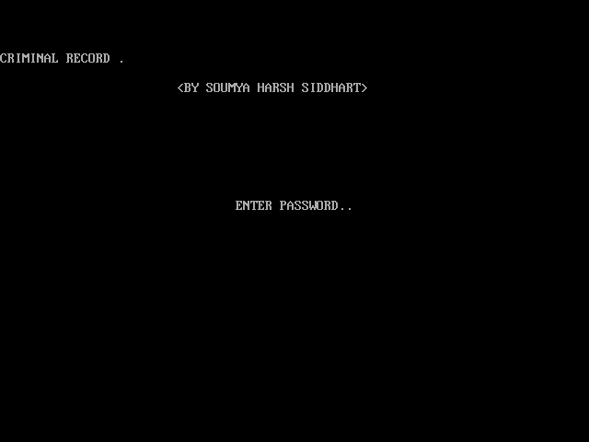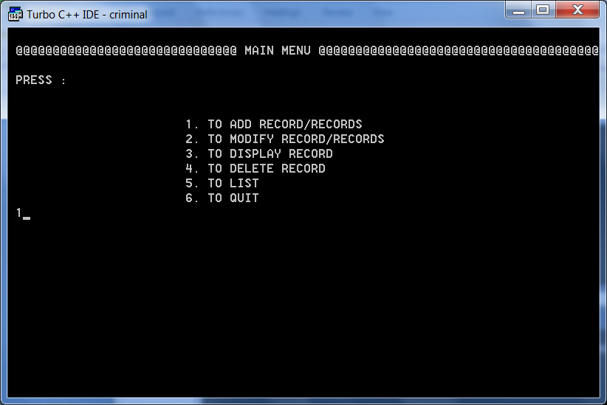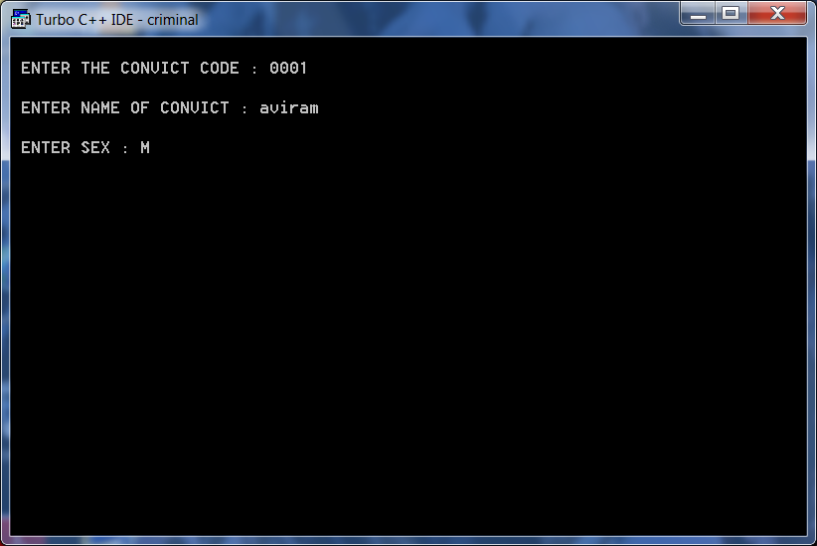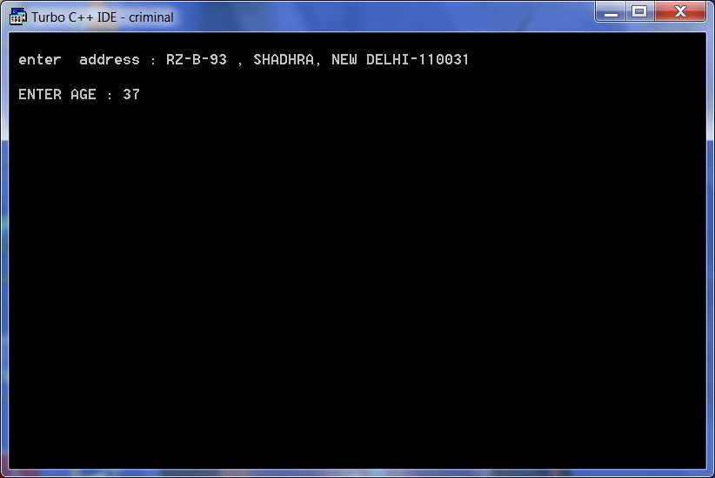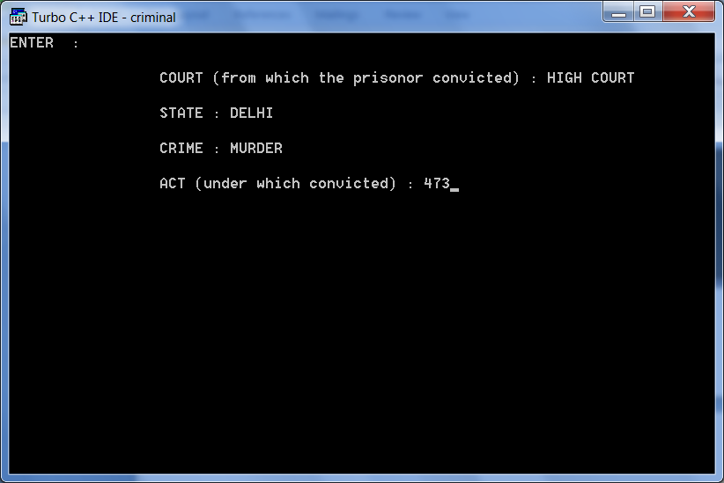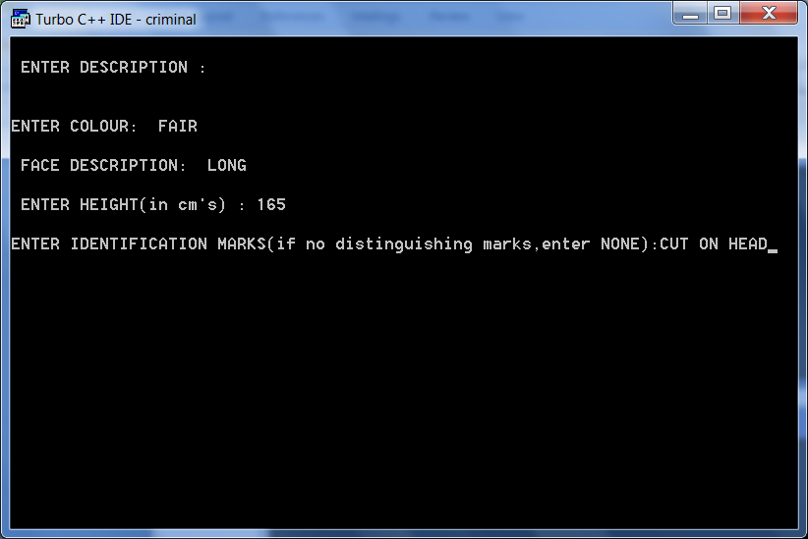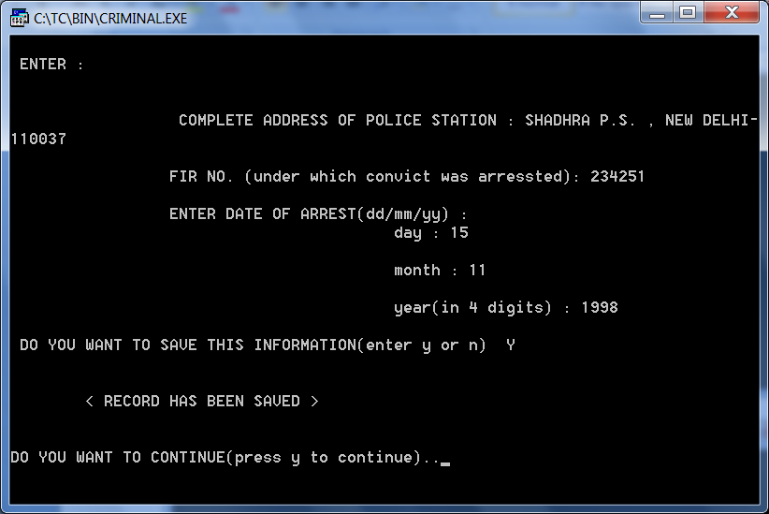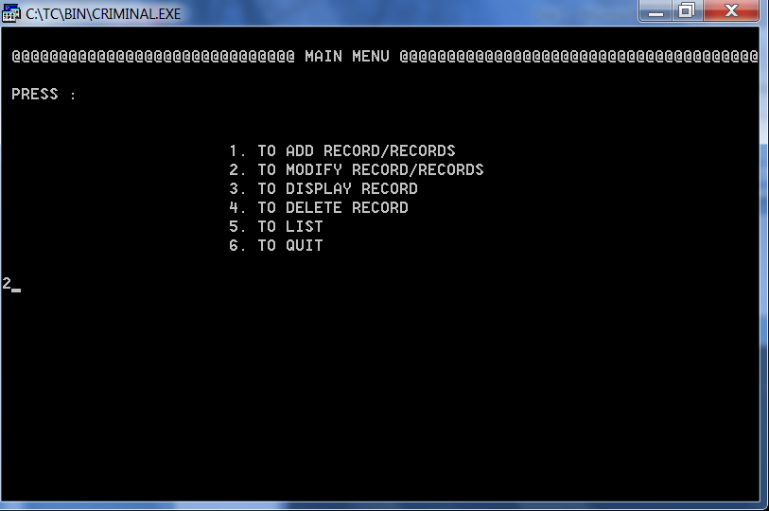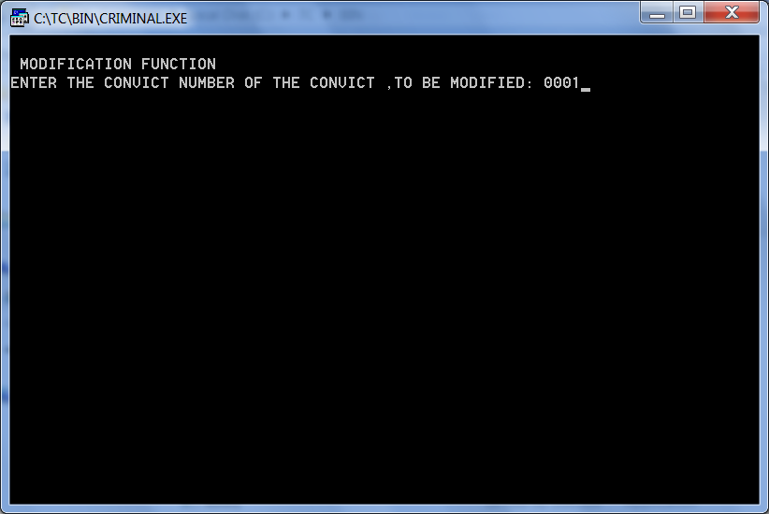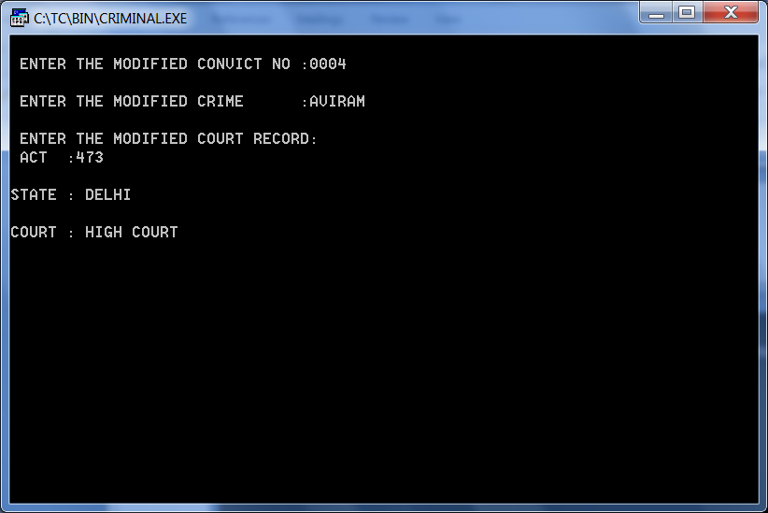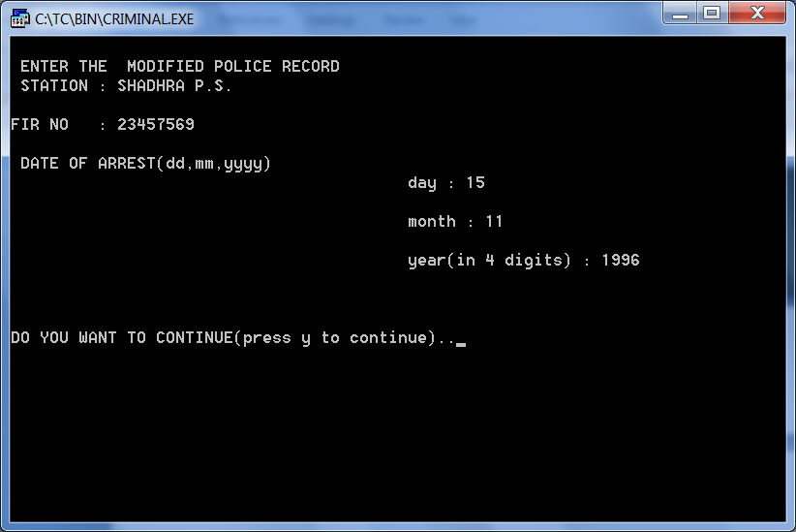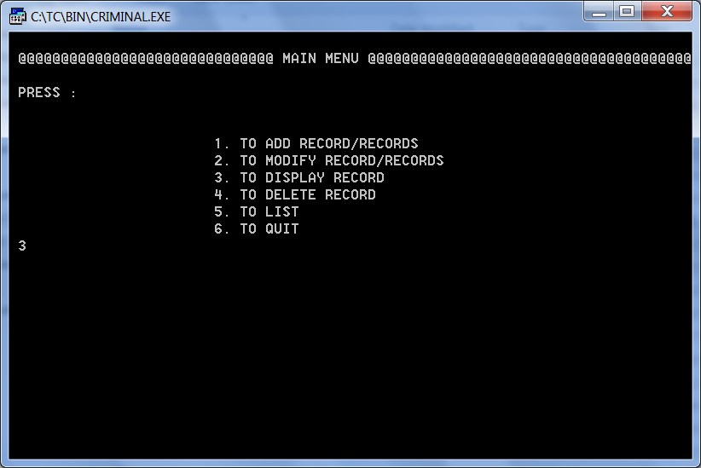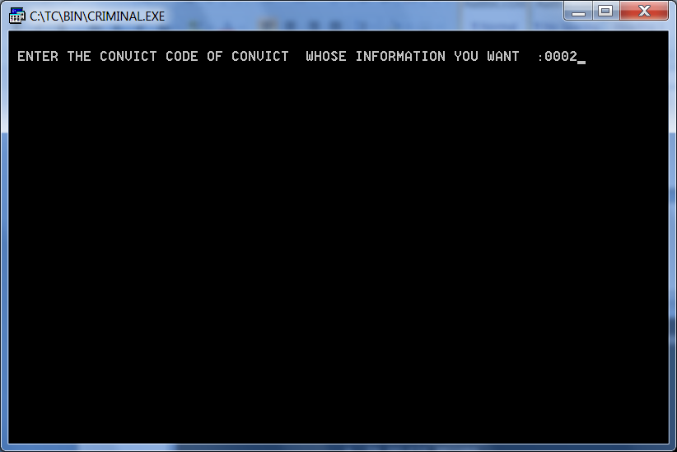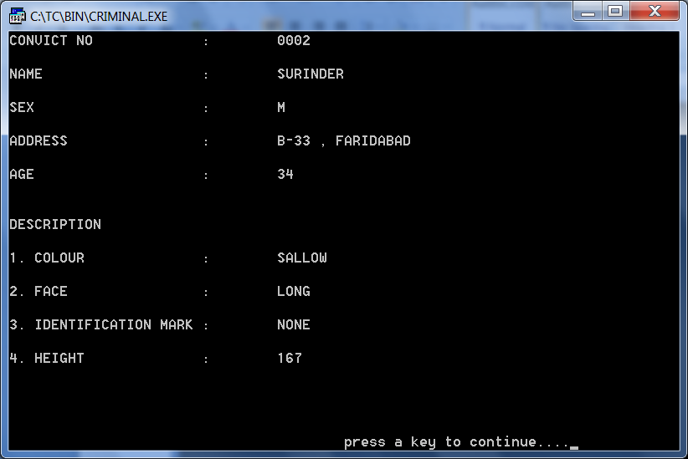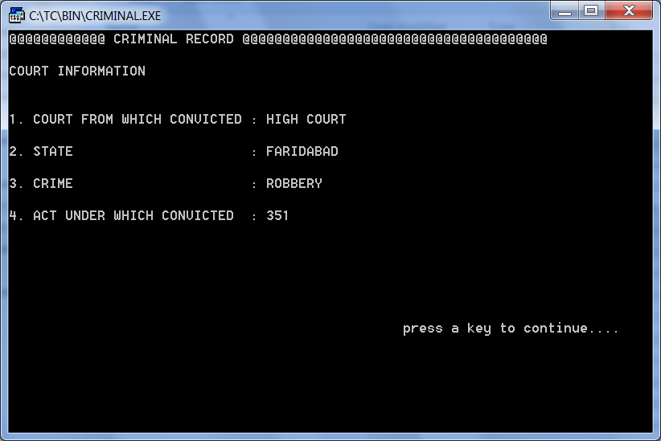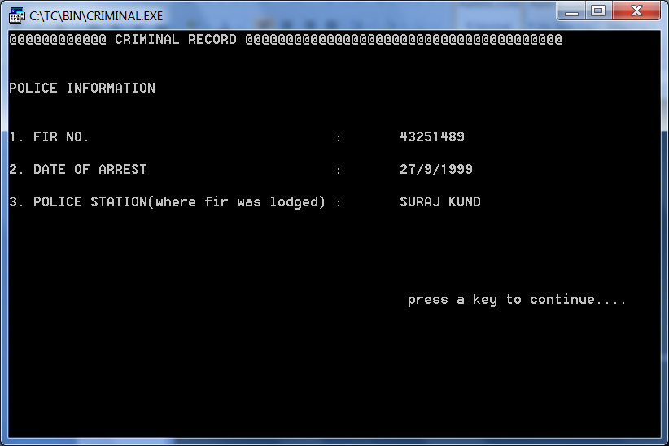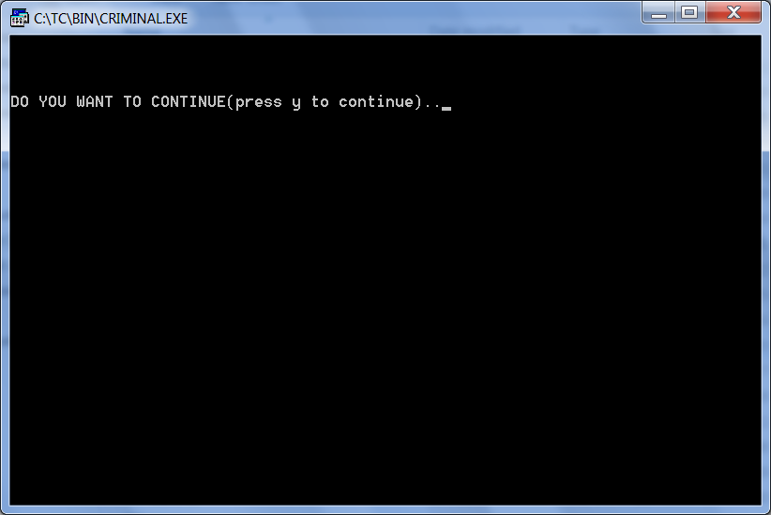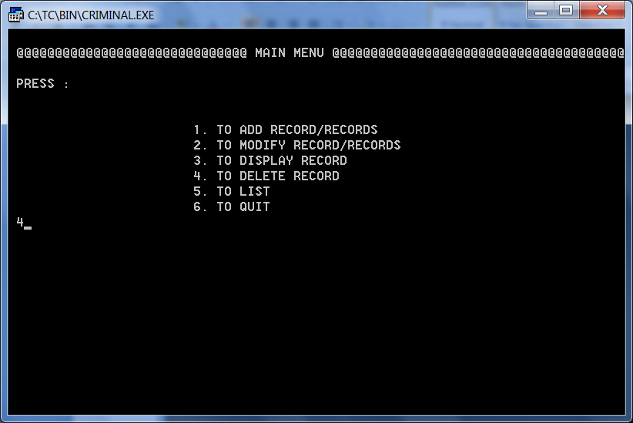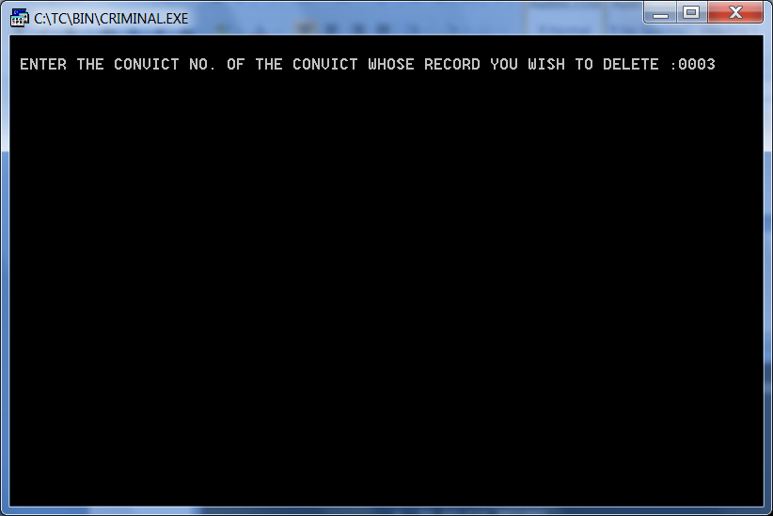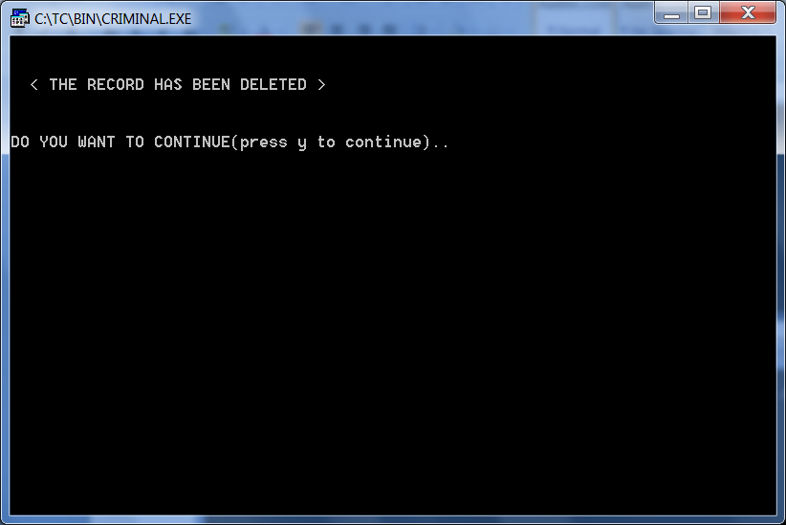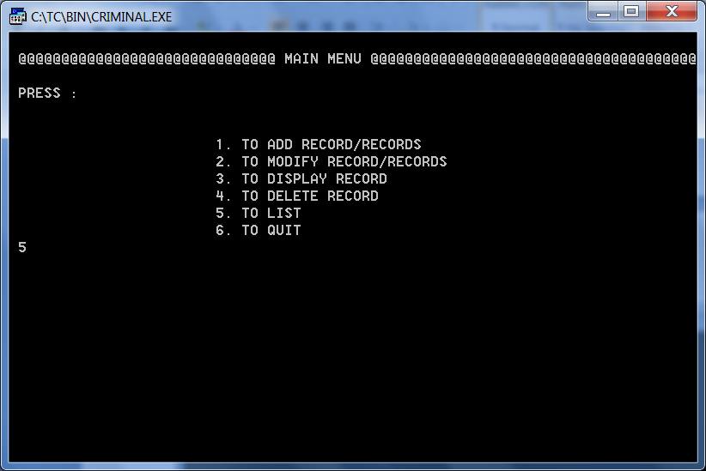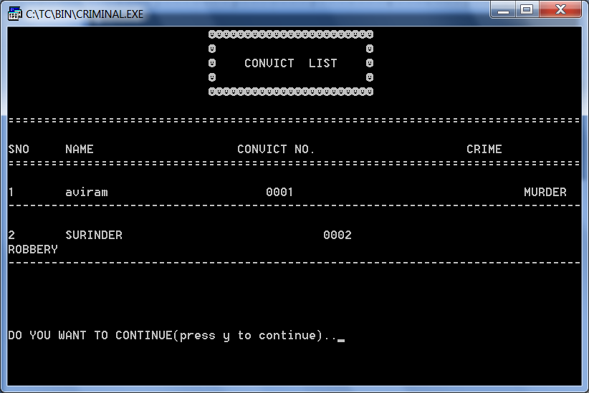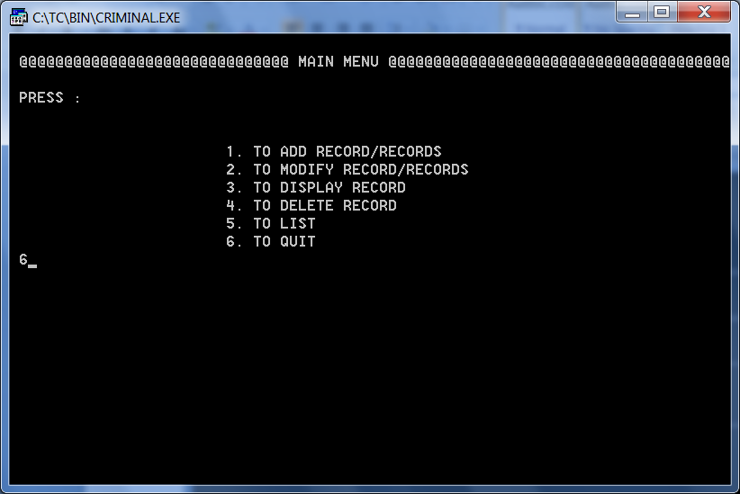

BIBLIOGRAPHY

1. Textbook XII-SUMITA ARORA (Part -1)
2. [www.classle.net](http://www.classle.net)
3. [www.cplusplus.com](http://www.cplusplus.com)
4. Wikipedia.org